Read two numbers and perform arithmetic operation using switch:
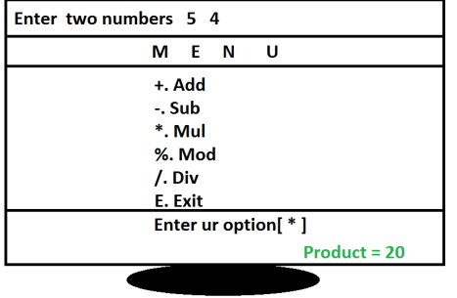
#include<stdio.h>
#include<conio.h>
#include<math.h>
void main()
{
float a,b;
char op;
abc:
clrscr();
printf("Enter two numbers "); scanf("%f %f",&a, &b);
puts("------------------------------------------------------------- -------");
puts("\t\t\t M E N U");
puts("------------------------------------------------------------- -------");
puts("\t\t\t + . Add");
puts("\t\t\t - . Sub");
puts("\t\t\t * . Mul");
puts("\t\t\t % . Mod");
puts("\t\t\t / . Div");
puts("\t\t\t E . Exit");
puts("------------------------------------------------------------- -------");
flushall();
printf("\t\t\t Enter Ur option[ ]\b\b");
scanf("%c",&op);
gotoxy(60,16); /* col, row */
switch(op)
{
case '+': printf("Sum=%.2f",a+b);break; case '-': printf("Sub=%.2f",a-b);break;
case '*': printf("Mul=%.2f",a*b);break;
case '%': printf("Mod=%.2f",fmod(a,b));break; case '/': printf("Div=%.2f",a/b);break;
case 'e': case 'E': return;
default: printf("Invalid option ");
}
getch(); goto abc; }
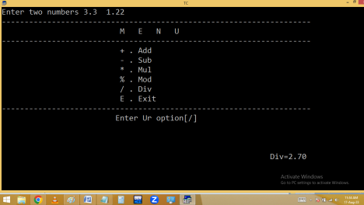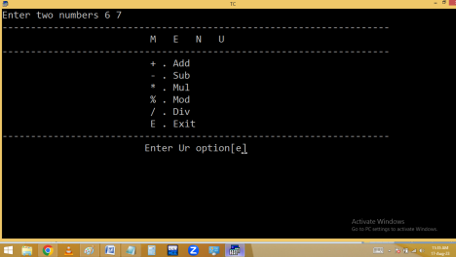
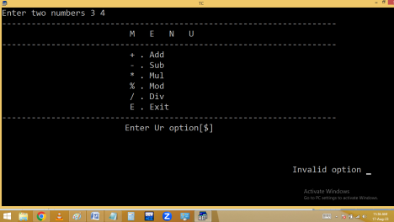
Loops / Iterations / Repetitive statements
Loops are used to repeat a block/group of statements continuously until the given condition becomes false.
Loops reduce program size and improves performance.
In loops beginning and ending points are same.
C-Language supports basically 2 types of loops.
1. Entry/pre controlled loops.
2. Exit/post controlled loops.
In entry control loops, condition is tested first and it is true then only statements block is executed.
Under entry control loops we are having
i. While loop
ii. For loop
In exit control loop, the statements are executed first and later condition is tested.
Under exit control loop we are having i. do while.
While loop:
⮚ while is a keyword.
⮚ In while loop condition is tested first and it is true then only while block statements are executed. After executing while block statements, the program execution automatically shifted/jumped to while condition at the beginning. If it is true then once again the while block statements are repeated. Like this the process is continued until while condition becomes false.
⮚ While is entry control loop.
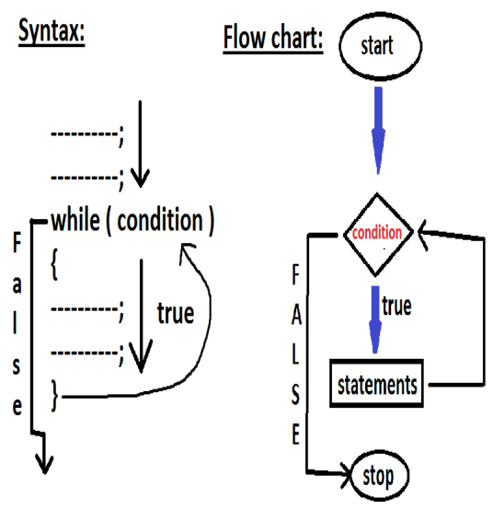
Printing 1..n natural numbers:
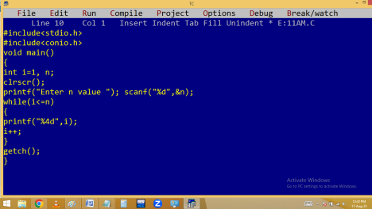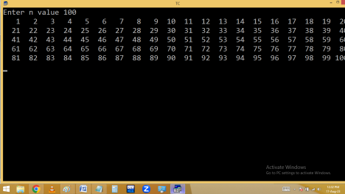
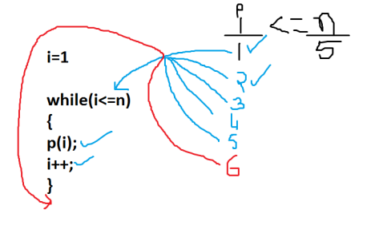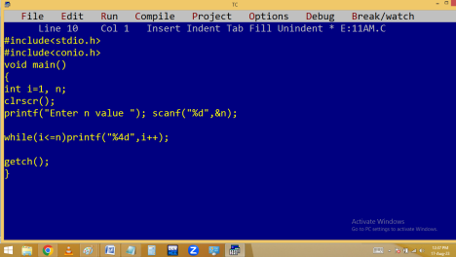
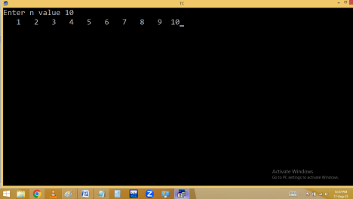
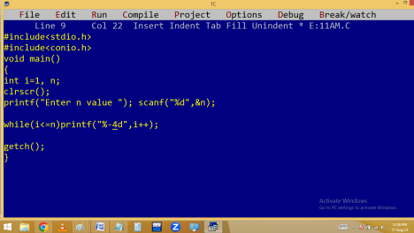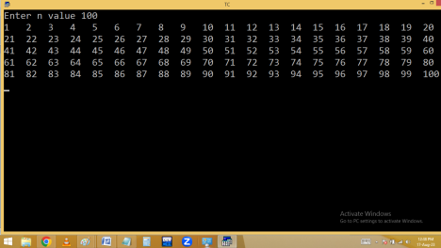
Printing 1..n numbers in reverse order.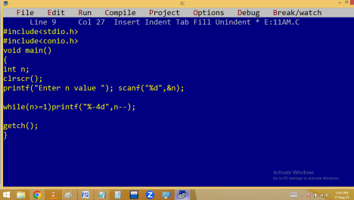
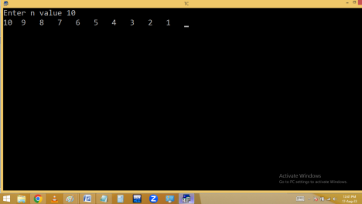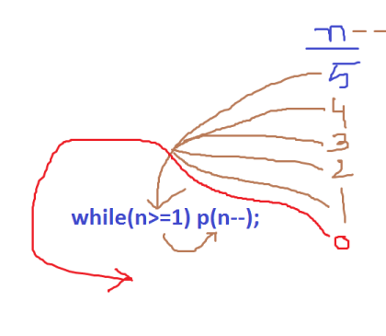
Printing 1..n even numbers.
Eg. printing 1..n odd numbers
Home work:
Finding 1..n numbers sum and avg [ mean ].
1 to 5 number sum = 15
15/5=3 is avg
Find 1..n even, odd numbers sum

